

**Sponsored by MHRD under the National Mission on Education through ICT program. An initiative by IIT Bombay that aims to create the next generation of embedded systems engineers with a practical outlook to help provide practical solutions to some of the real world problems.**

**e-Yantra Lab Setup Initiative (eLSI)**

**VISION**

e-Yantra Lab Setup Initiative (eLSI) is a college level program under which colleges are encouraged to setup robotics labs. AIET is privileged to be a part of this initiative since 2013. Our college has conducted a workshop on robotics to students for the consecutive two years. This workshop has helped our students in knowing the basics and programming a robotic kit

#### ****e-Yantra Robotics Competition(eYRC)****

e-Yantra Robotics Competition (eYRC) is a unique annual competition for undergraduate students in science and engineering colleges. Selected teams are given a robotic kit complete with accessories and video tutorials to help them learn basic concepts in embedded systems and microcontroller programming. Abstracts of real world problems assigned as "themes" are then implemented by the teams using the robotic kits. **The winners of this competition will get a cash prize and offered summer internship at IITB through e-Yantra Summer Internship Program.**

AIET has always encouraged its students to take part in e-yantra robotics competition.

**e-YRC 2014 Competition**

In the e-Yantra robotics Competition 2014 all the final year Project batches of ECE department Participated event only one batch cleared prelims and bagged 7th position in the final. The theme assigned for the batch was "Fire Fighting Robot” they were awarded with Successful Completion Certificate from IIT Bombay.

|  |  |  |  |  |
| --- | --- | --- | --- | --- |
| # | Name | USN | Title | Guide |
| 1 | Nizammuddin | 4AL11EC033 | Fire Fighting Robot | Mr. Santhosh S. |
| 2 | D Souza Deepakraj | 4AL11EC024 |
| 3 | Darshan D N | 4AL11EC019 |
| 4 | Kanthesh Jogi | 4AL11EC031 |

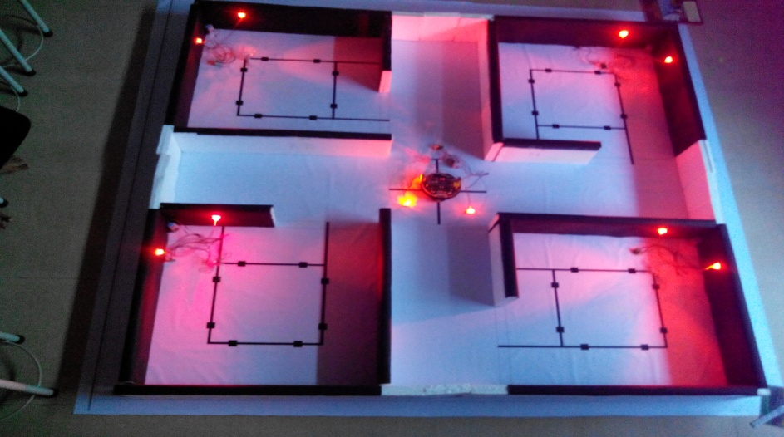

Fig: Fire fighting Robot Arena

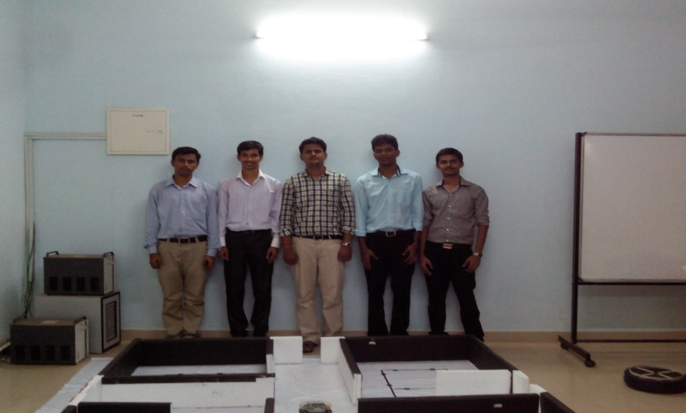

Fig: e-YRC 2014 Team

**e-YRC 2015 Competition**

In the e-Yantra robotics Competition 2015 all the final year Project batches of ECE department Participated but no one cleared prelims.

**e-YRC 2016 Competition**

|  |  |  |  |  |
| --- | --- | --- | --- | --- |
| # | Name | USN | Title | Guide |
| 1 | Anoop Raj A R | 4AL12EC017 | **Search and Rescue Robot** | Mr. Santhosh S. |
| 2 | Chaitra M | 4AL12EC026 |
| 3 | ChetanSuvarna | 4AL12EC027 |
| 4 | RoopaMotilalRahod | 4AL12EC064 |

In the e-Yantra robotics Competition 2016 all the final year Project batches of ECE department Participated and 5 batches cleared prelims. All the five batches attended second round but two batches cleared for third round. Assigned theme for both the batches was **“Search and Rescue Robot”.** Both the batches not cleared 3rd round of the competition

|  |  |  |  |  |
| --- | --- | --- | --- | --- |
| # | Name | USN | Title | Guide |
| 1 | AtionRoja H N | 4AL12EC024 | **Search and Rescue Robot** | Mr. Santhosh S. |
| 2 | Ria Vinitha Dsouza | 4AL12EC063 |
| 3 | Anchan Divyalaxmi Diwakar | 4AL12EC015 |
| 4 | Rashmitha M | 4AL12EC061 |

**e-YRC 2017 Competition**

In the e-Yantra robotics Competition 2017 all the final year Project batches of ECE department Participated and only one batch got selected in the prelims. The selected batch then cleared second and third task assigned under the theme called “**Feeder Weeder robot”.** In the finals they bagged second prize in the sixth edition of National-level e-Yantra Robotics Competition (eYRC-2017) held at IIT Bombay from March 22 to 24.

|  |  |  |  |  |
| --- | --- | --- | --- | --- |
| # | Name | USN | Title | Guide |
| 1 | Arun Kumar | 4AL14EC011 | **Feeder Weeder Robot** | Mr. Santhosh S. |
| 2 | Chethak | 4AL14EC023 |
| 3 | Deepika | 4AL14EC027 |
| 4 | Rohan Sonal Dsouza | 4AL13EC067 |

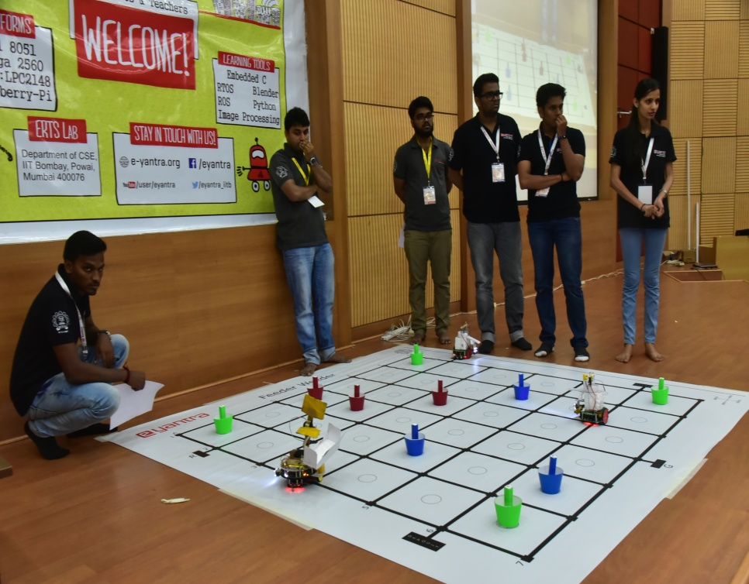

Fig: Feeder Weeder Robot Arena

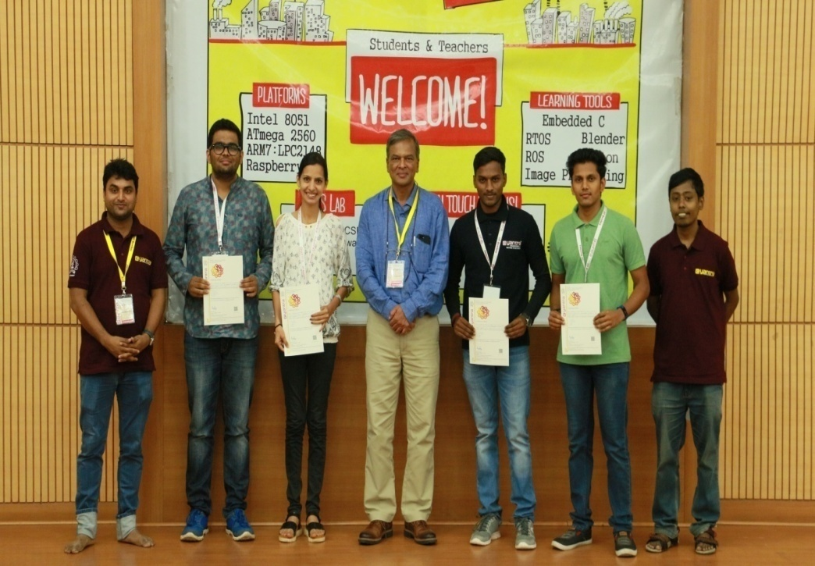

Fig: Fig: e-YRC 2017Team

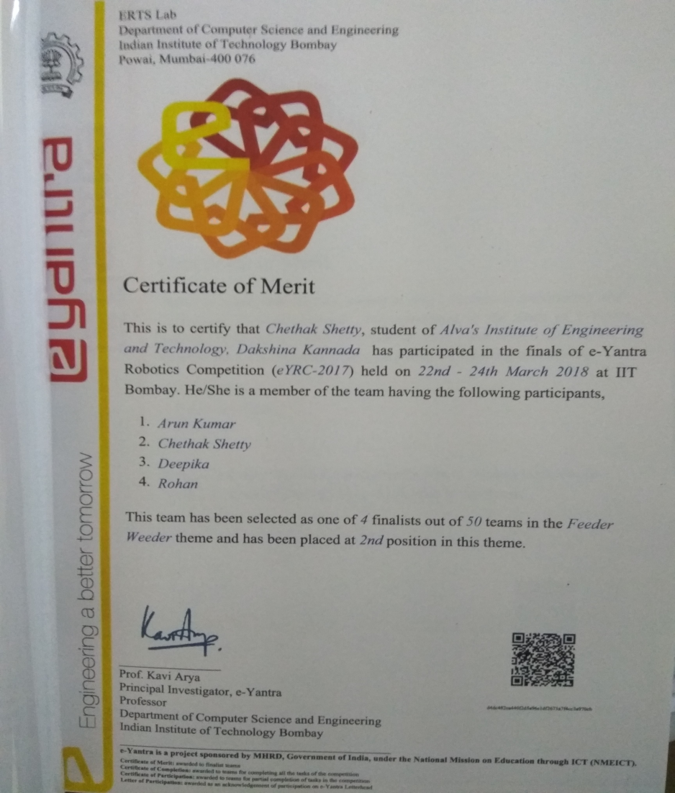

Fig: Certificate of Merit Received

